Lean Specification

Conversion – Location- (O2_GENAI_CNV410)

Document Control Information

Document Information

|  |  |
| --- | --- |
| Document Identification | O2_GENAI_CNV410 |
| Document Name | O2_GENAI_CNV410_Location |
| Project Name |  |
| Client | **XXX** |
| Document Author |  |
| Document Version | V1.0 |
| Document Status | Draft |
| Date Released |  |

Document Edit History

| Version | Date | Additions/Modifications | Prepared/Revised by |
| --- | --- | --- | --- |
| 1.0 | 06/05/2024 | Initial version | Shubham Bhapkar |
|  |  |  |  |
|  |  |  |  |

Document Review/Approval History

| Date | Name | Organization/Title | Comments |
| --- | --- | --- | --- |
|  |  |  |  |
|  |  |  |  |
|  |  |  |  |
|  |  |  |  |
|  |  |  |  |
|  |  |  |  |
|  |  |  |  |

Distribution of Final Document

The following people are designated recipients of the final version of this document:

| Name | Organization/Title |
| --- | --- |
|  |  |
|  |  |
|  |  |
|  |  |
|  |  |

Contents

1 Conversion Summary 5

1.1 Purpose/Justification 5

1.2 Conversion Description and Overview 5

1.3 Definitions and Acronyms 5

2 Functional design 6

2.1 Conversion Details 6

2.2 Data Selection and Sorting 6

2.3 Referenced User Stories 6

2.4 Data Mapping 6

2.5 Conversion Logic 7

2.6 Error Handling Logic 7

2.7 Assumptions 7

2.8 Dependencies 7

2.9 Reconciliation 8

2.10 Post Conversion steps 8

3 Technical Design Specifications 9

3.1 Overview <Mandatory> 9

3.2 Source system extraction Design <Mandatory> 9

3.3 Data cleansing mechanism <Mandatory> 9

3.4 Transformation requirements <Mandatory> 9

3.5 Load method into target 9

3.6 Error Handling <Mandatory> 11

4 Technical Reconciliation reports <Mandatory> 12

5 Unit testing 13

5.1 Technical unit testing 13

5.1 Functional unit testing 13

6 Open Items 15

# Conversion Summary

## Purpose/Justification

This document forms the basis for detailed functional and technical design to develop logic for conversion of Locations from MDM to Oracle Fusion Cloud ERP.

This functional design document is intended to provide the developer all the key information, assumptions, rules, and logic that are required to accurately fetch the Location details from MDM system to Oracle Fusion Cloud ERP application.

Locations from all geographic regions will be included as part of this conversion. A new Reference Data set MDMREFDATASET will be created and all converted MDM locations will be assigned to this Reference Data Set.

## Conversion Description and Overview

All active Non-Revenue locations referenced by different processes including Procure to Pay, Order to Cash, FAH including DFFs will be converted from the MDM system to Oracle Fusion Cloud ERP.

All Revenue Locations will be converted during G-Systems Go-Live and will be handled on another object.

For Location conversion Oracle standard ADFDI spreadsheet will be used.

## Definitions and Acronyms

|  |  |
| --- | --- |
| Acronym | **Meaning** |
| MDM | Master Data Management |
| ADFDI | Application Development Framework Desktop Integration |
| DFF | Descriptive Flex Field |
|  |  |

# Functional design

## Conversion Details

|  |  |
| --- | --- |
| Conversion Source | MDM |
| Conversion Target | Oracle Fusion Cloud ERP |
| Conversion Method | Location ADFDI Spreadsheet |
| Expected Volume | TBD |

## Data Selection and Sorting

All Active Locations from MDM will be converted with the relevant attributes

## Referenced User Stories

|  |  |
| --- | --- |
| User Story ID |  |
|  |  |
|  |  |
|  |  |

## Data Mapping

 

## Conversion Logic

|  |  |
| --- | --- |
| S. No. | **Description** |
| 1 | Extract Active location data from the MDM system |
| 2 | Enter the location data in Oracle Cloud ADFDI location template |
| 3 | Validate the data and create data set |
| 4 | Import the data into Oracle Cloud |

## Error Handling Logic

Error handling in case of data conversions is a manual process. Once the data is loaded and there are any failures encountered, each of those errors will be discussed with the process/ object owners and Point of Contacts over a meeting to identify the root cause and corrective action.

Corrective action can be but not limited to:

1. Data cleansing at source
2. Configuration update in Oracle Cloud
3. Extraction criteria change

Each of these corrective actions will be captured in the conversion runbook.

## Assumptions

1. MDM is the primary source of the locations information
2. Only Active locations will be converted to Oracle Fusion Cloud ERP
3. All attributes as agreed to in the mapping files will be included as part of the conversion
4. A new Reference Data Set MDMREFDATASET will be created for MDM Locations
5. Locations need to be assigned to Reference Data Sets and all MDM Locations will be assigned to MDMREFDATASET
6. All Locations with a future end date horizon will have end date set as the Oracle default end of time i.e. 4712-12-31
7. As some attributes would have tax implications, it is to be ensured that none of these attributes are missing. All components of address should be converted. For example: Canada addresses should have Province mandatorily. For US, State and City is mandatory.

## Dependencies

1. All Required DFF are created in the application.
2. Business Unit, Ledger and Legal entity are defined in the application.
3. MDMREFDATASET has been created in the system
4. Locations Reference Data Set configuration in Manage Set Assignments is set to MDMREFDATASET

## Reconciliation

|  |  |
| --- | --- |
| S. No. | **Actions to be performed** |
| 1 | Accuracy Check: On Screen Sample Validation ‘Spot Checking’: The business should pick some sample records and validate each data field on the screen. The comparison should be done for the same record in Oracle and legacy systems. |
| 2 | Completeness Check: Verify the number of Locations created in total. Check how many locations have been created.   * + Total number of records received in the source file   + Total number of records successfully loaded to Oracle   Any differences between the extracted numbers and the number of records migrated should be captured in the reconciliation report with reason of failure and resolution for the issue. |

## Post Conversion steps

|  |  |
| --- | --- |
| S. No. | **Actions to be performed** |
| 1 | For the purpose of reconciliation, following details will be shared with business owner:  Pre-conversion MDM system data extract  Post-conversion Cloud data extract  Run Summary: Total, Success, Failure  Error Report in case of failures  Business owner should use this data to reconcile and share any findings or provide approval on the data conversion. |

# Technical Design Specifications

## Overview

NA

## Source system extraction Design

NA

## Data cleansing mechanism

NA

## Transformation requirements

NA

## Load method into target

Setup and Maintenance> Manage Locations

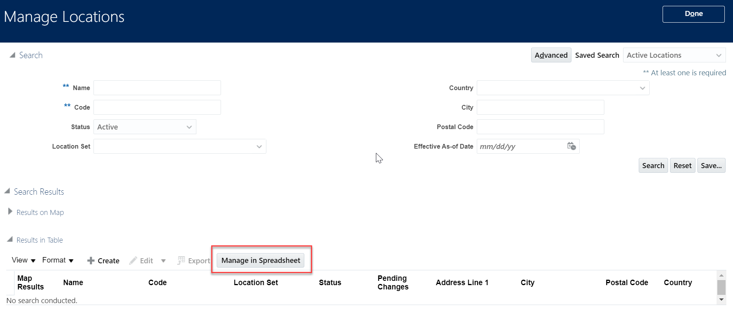

Open the excel and enter username password to enter data:

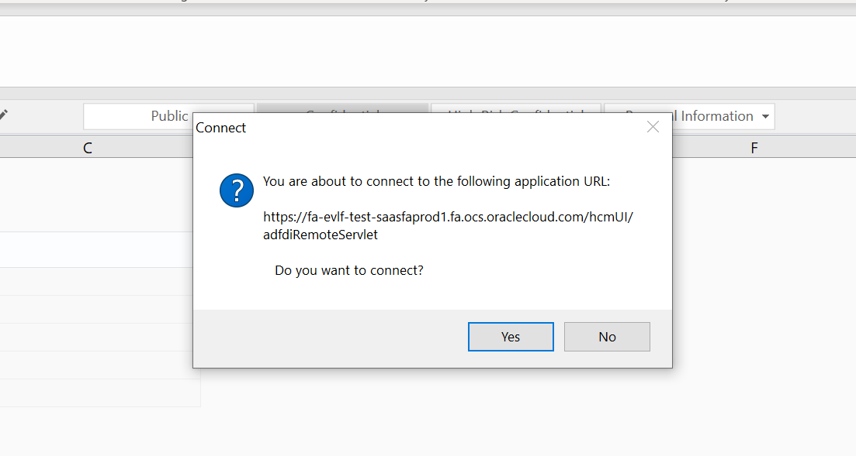

Click on create data set:

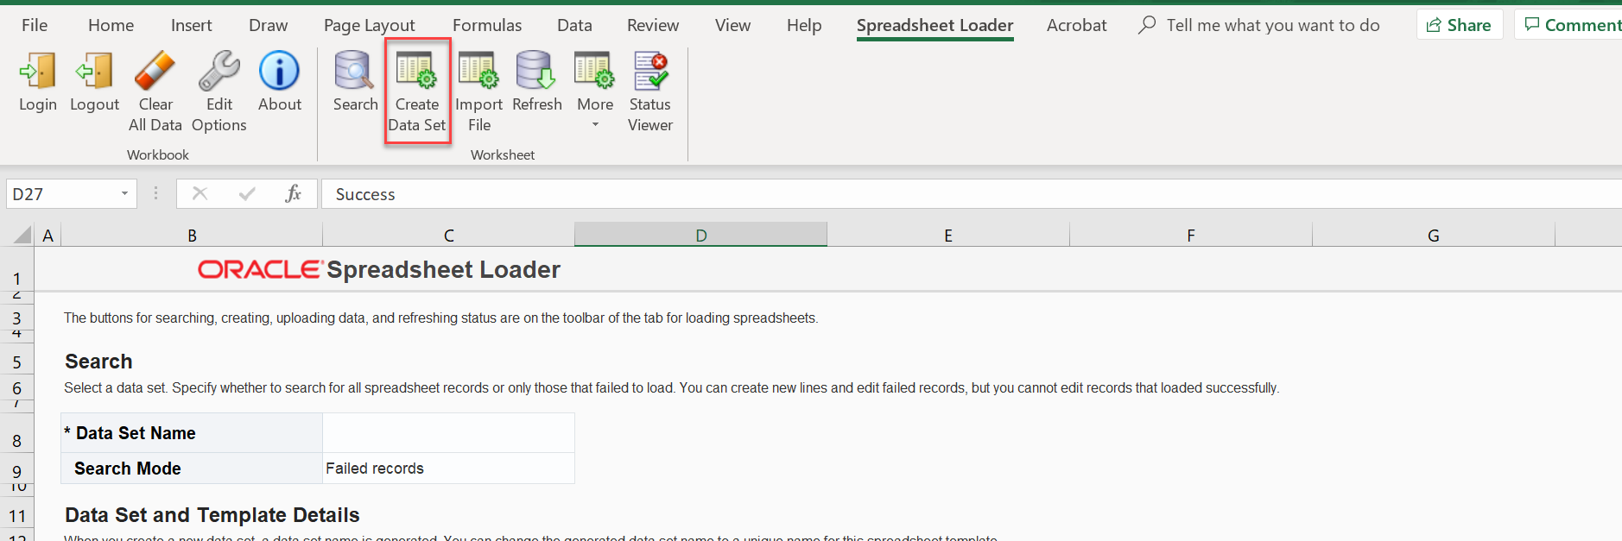

Data set is created, enter the data in the columns and Upload.

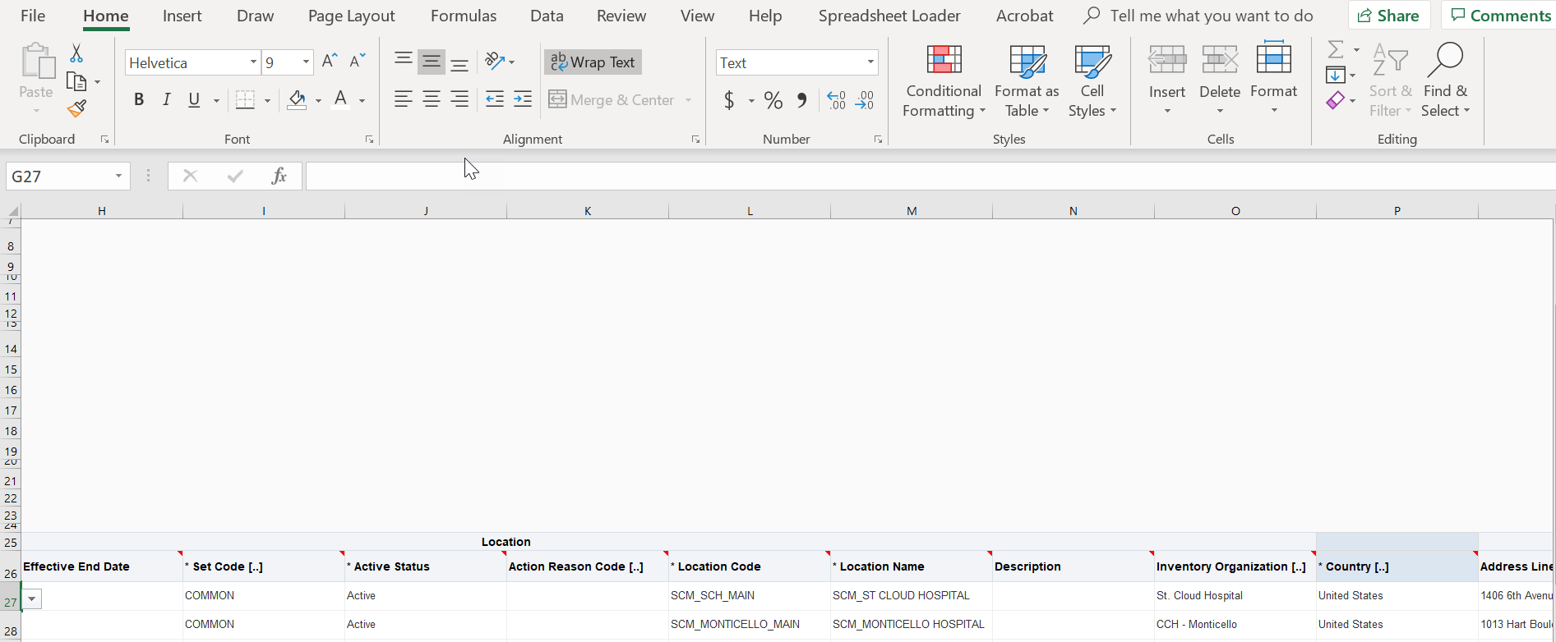

Data is loaded through Spreadsheet Successfully.

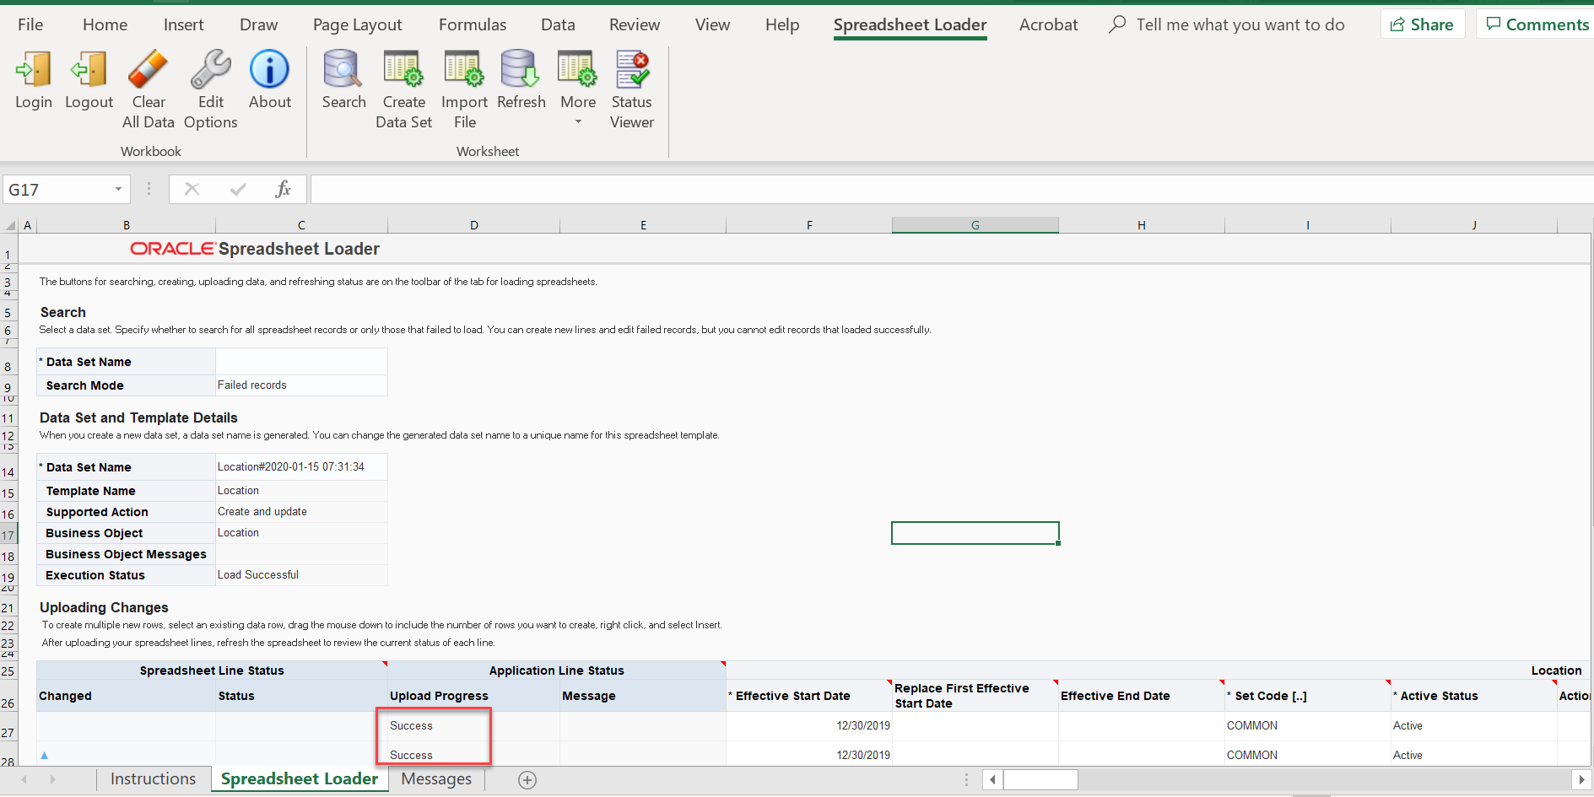

## Error Handling

|  |  |  |
| --- | --- | --- |
| S. No. | **Condition** | **Action** |
|  |  |  |
|  |  |  |
|  |  |  |

# Technical Reconciliation reports

|  |
| --- |
| **Recon Report: SQL query** |
|  |

# Unit testing

## Technical unit testing

|  |  |  |
| --- | --- | --- |
| S. No | Scenario | Expected Result |
|  |  |  |
|  |  |  |

## 5.1 Functional unit testing

|  |  |  |
| --- | --- | --- |
| S. No | Scenario | Expected Result |
| ~~1~~ | Update address on converted MDM location | Change done successfully |
| ~~2~~ | ~~Update address on Existing (converted) HR location*~~ | ~~Change done successfully~~ |
| ~~3~~ | ~~Create a new Non-HR Location~~ | ~~New location is successfully created~~ |
| ~~4~~ | ~~Create a new HR Location*~~ | ~~New location is successfully created~~ |
| 5 | Close/ end-date/ inactivate converted MDM location | Existing location is successfully end dated |
| ~~6~~ | ~~Close/end-date/inactivate existing (converted) HR location*~~ | ~~Existing location is successfully end dated~~ |
| ~~7~~ | ~~Update address on Existing (converted) non-HR location~~ | ~~Change done successfully~~ |
| 8 | Updated Ship to site and Bill to site flag to “Yes” for required Locations. | Change done successfully |
| 9. | Update a Custom Attribute on the converted MDM Location | Change Done Successfully |
| 10. | Create a PO and select a location belonging to a different Reference Data Set | Location should not be available in the List of Values |

# Open Items

|  |  |  |  |  |  |
| --- | --- | --- | --- | --- | --- |
| Date Reported | Status | Question | Resolution | Due Date | Responsible Party |
|  |  |  |  |  |  |
|  |  |  |  |  |  |
|  |  |  |  |  |  |
|  |  |  |  |  |  |
|  |  |  |  |  |  |
|  |  |  |  |  |  |
|  |  |  |  |  |  |

# Appendix